installing Docker Hub

procedure

1. <https://docs.docker.com/desktop/install/windows-install/>

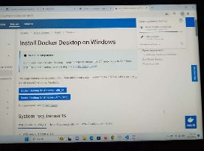

1. Docker Desktop for Windows - x86_64

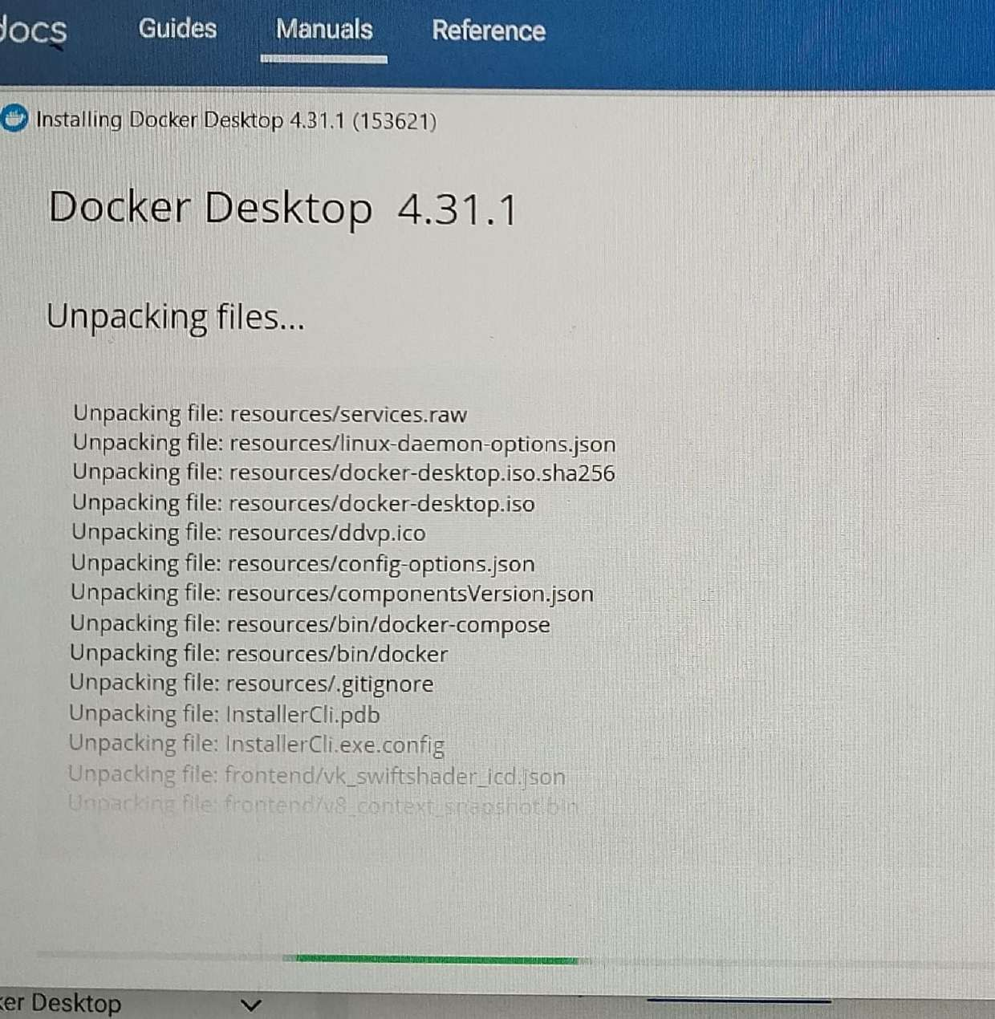

3. Restart the computer to save the changes

Installing MySQL

1. <https://dev.mysql.com/downloads/windows/installer/5.7.html>

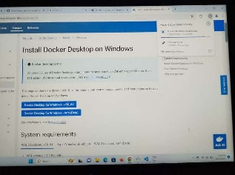

Click on No thanks, just start my download.

3. Install Windows (x86, 32-bit), MSI Installer Version 5.7.4 (373.7M

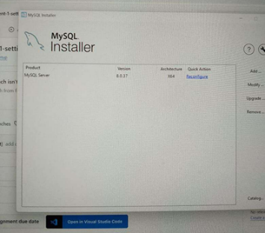

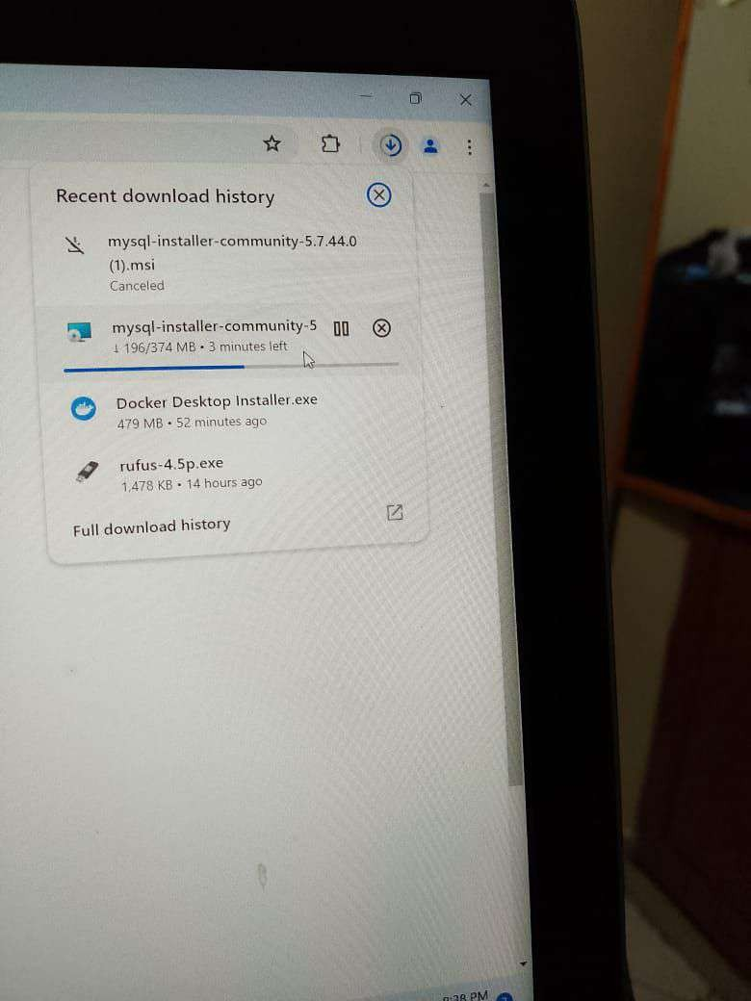4. Once Downloaded, click on logging options then next

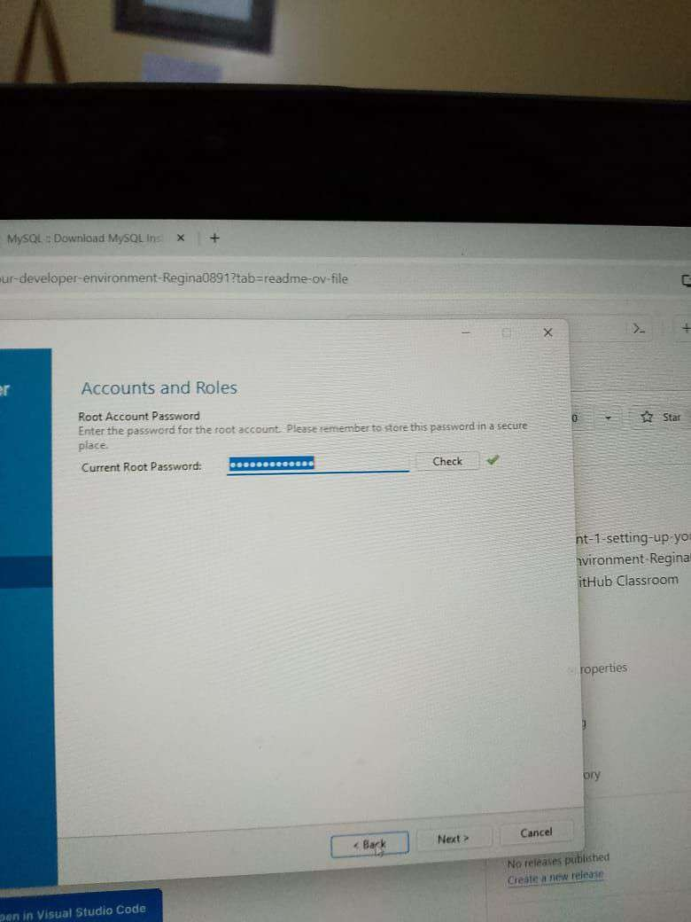

5. Click on Reconfigure

6. Click on Type and Networking then click next

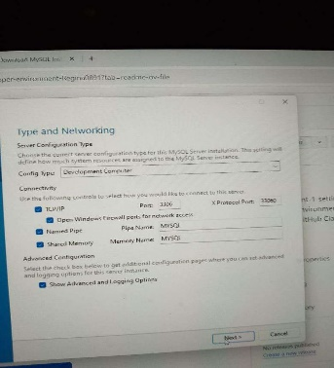

7. Named Pipe then click next

8. Click Authentication method, Check Password then click n

9. Windows service then next

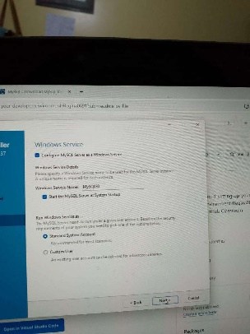

10. Apply configuration then Execute, then click Finish